

24ADC001- BUSINESS INTELLIGENCE

--------------------------------------------------

2026-2027
LAB RECORD

DEPARTMENT OF ARTIFICIAL
INTELLIGENCE AND DATA SCIENCE

INDEX
Expt. No | Title of the Experiment | Page No | Total  Marks | Faculty Signature
1. | Explore the interface and basic features of the BI tool
2. | Load and visualize a sample dataset.
3. | Import a dataset into the BI tool. And Cleanse data by handling missing values, outliers, and inconsistencies.
4. | Transform data to suit BI reporting requirements and Design a dashboard with key performance indicators (KPIs).
5. | Develop interactive dashboards for dynamic data exploration.
6. | Integrate data from various sources for comprehensive analysis
7. | Implement advanced chart types (treemaps, heatmaps, etc.).
8. | Apply BI tools for forecasting and predictive analytics.

Average marks Faculty Signature

EXPT NO:1 | EXPLORE THE INTERFACE AND BASIC FEATURES OF BI Tool
DATE: 10.07.2026 | EXPLORE THE INTERFACE AND BASIC FEATURES OF BI Tool

PRE-LAB QUESTIONS (PROVIDE BRIEF ANSWERS TO THE FOLLOWING QUESTIONS)

- What is the purpose of Business Intelligence (BI) tools like Tableau and Power BI?
Answer: Business Intelligence (BI) tools like Tableau and Power BI help collect, analyse, and visualize data. They convert raw data into meaningful reports and dashboards, enabling organizations to make informed business decisions.

- List any three common data sources that Tableau and Power BI can connect to.
Answer: Three common data sources are Microsoft Excel, SQL Server databases, and CSV files. Both tools can also connect to cloud services and online databases.

- What is a dashboard in BI, and how is it different from a single chart?
Answer: A dashboard is a collection of multiple charts, KPIs, and visualizations displayed on one screen. Unlike a single chart, it provides a complete overview of business performance.

4(a). Define Visualization.
Answer: Visualization is the graphical representation of data using charts, graphs, maps, or tables. It helps users easily identify trends, patterns, and relationships in the data.

4(b). Define KPI.
Answer: A Key Performance Indicator (KPI) is a measurable value used to evaluate the performance of a business or process. It helps track progress toward specific goals.

4(c). Define Data Filter.
Answer: A data filter is a feature that displays only selected data based on specified conditions. It helps users focus on relevant information while excluding unnecessary data.

- Why is it important to clean and transform data before visualization?
Answer: Cleaning and transforming data removes errors, duplicates, and missing values. It ensures that the visualizations are accurate, reliable, and easy to interpret.

- What kind of chart would you use to analyze stock price trends over time?
Answer: A Line Chart is the most suitable chart for analyzing stock price trends over time. It clearly shows changes in stock prices across different time periods.

- Explain the role of slicers in Power BI and filters in Tableau.
Answer: Slicers in Power BI and filters in Tableau allow users to interactively display specific subsets of data. They make dashboards more flexible and easier to analyze.

8 . What does a calculated field or measure do in BI tools?
Answer: A calculated field or measure performs custom calculations using existing data. It helps create new metrics such as profit, growth percentage, or averages for analysis.
9. What are the advantages of using interactive dashboards for financial data analysis?
Answer: Interactive dashboards allow users to explore financial data, apply filters, and monitor KPIs in real time. They improve analysis and support faster decision-making.

10. Which function would you use to find the absolute difference between predicted and actual stock prices?
Answer: The ABS() function is used to calculate the absolute difference between predicted and actual stock prices. It always returns a positive value regardless of the result's positivity.

IN-LAB EXERCISE:

Objective:
To understand the basic interface, data import process, and fundamental visualization capabilities of Tableau and Power BI using a stock prediction dataset, and to explore their usefulness in analyzing financial data.

Tools Required:
- Tableau Public / Tableau Desktop
- Power BI Desktop
- Sample Dataset (CSV/Excel) containing:
Date, Stock Name, Open, Close, High, Low, Volume, Predicted Price

Exercise Steps:
Part 1: Working with Tableau
- Launch Tableau and connect to the stock prediction dataset.
- Explore the Interface: o Understand components like Data Pane, Sheets, Marks Card, and Dashboards.
- Create Basic Visualizations:
  - Line Chart: Show Close Price over time.

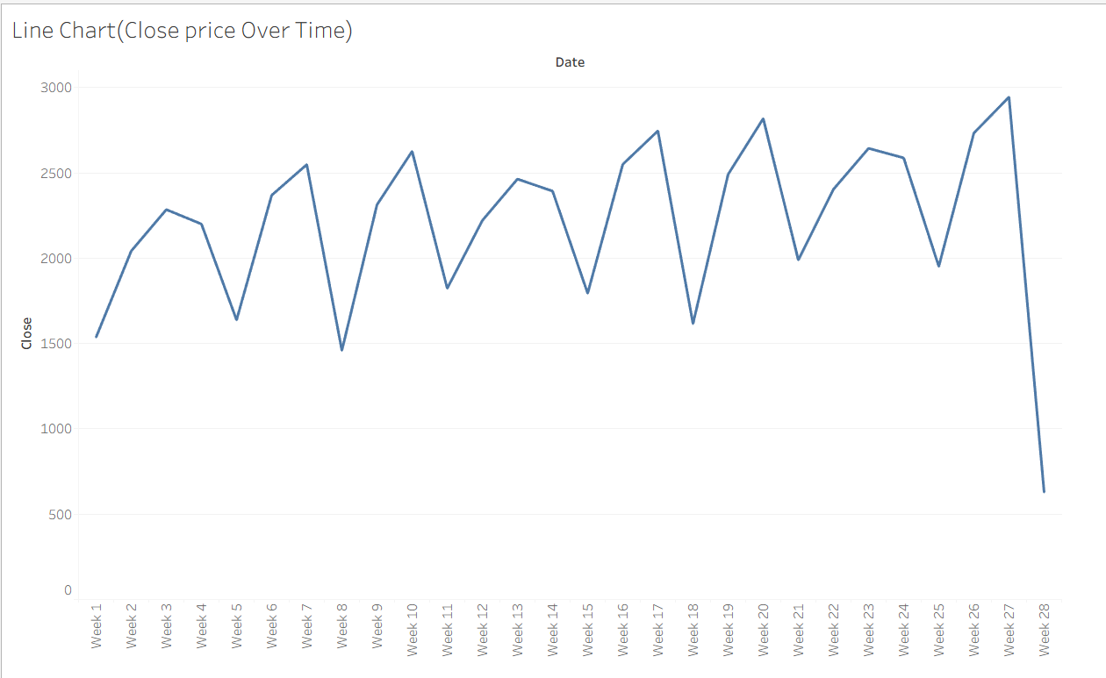
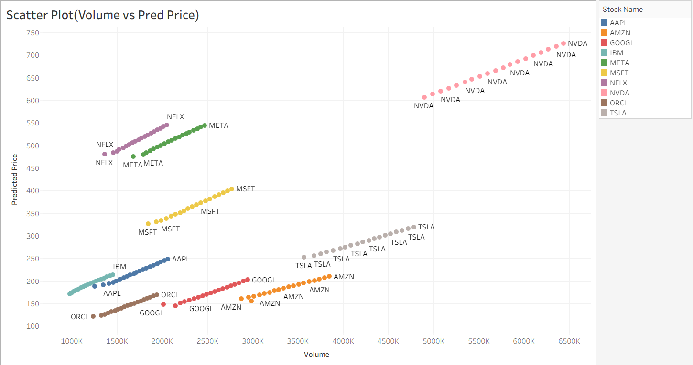
  - Scatter Plot: Plot Volume vs. Predicted Price.

  - Highlight Table: Display Predicted Price by stock.
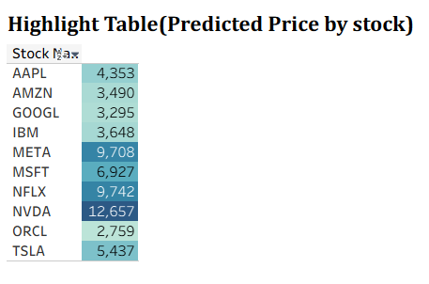
- Apply Filters:
  - Add filters for Stock Name and Date Range.

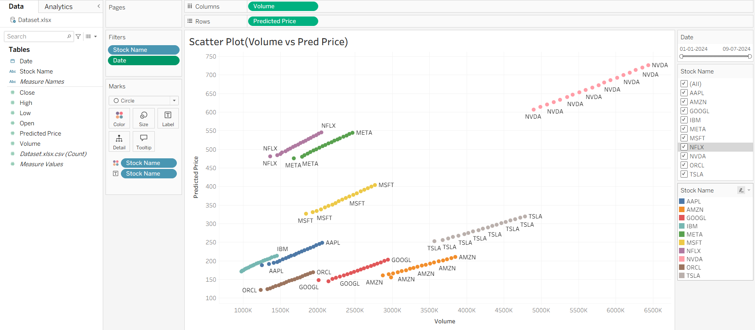

- Create Calculated Field: o Calculate prediction error as |Predicted - Close|.
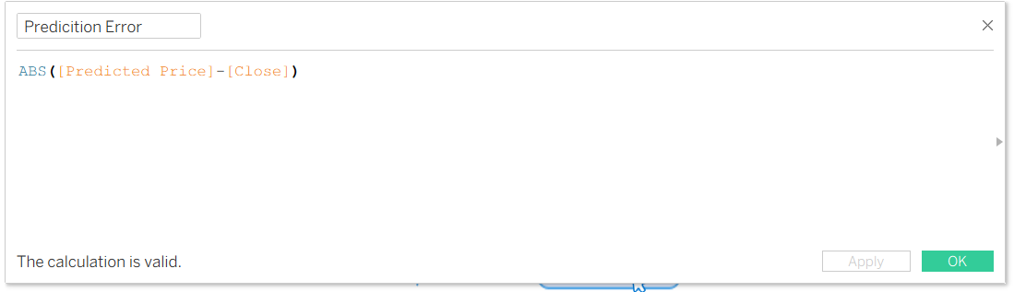
- Design a Basic Dashboard:
  - Combine your charts into one interactive dashboard.
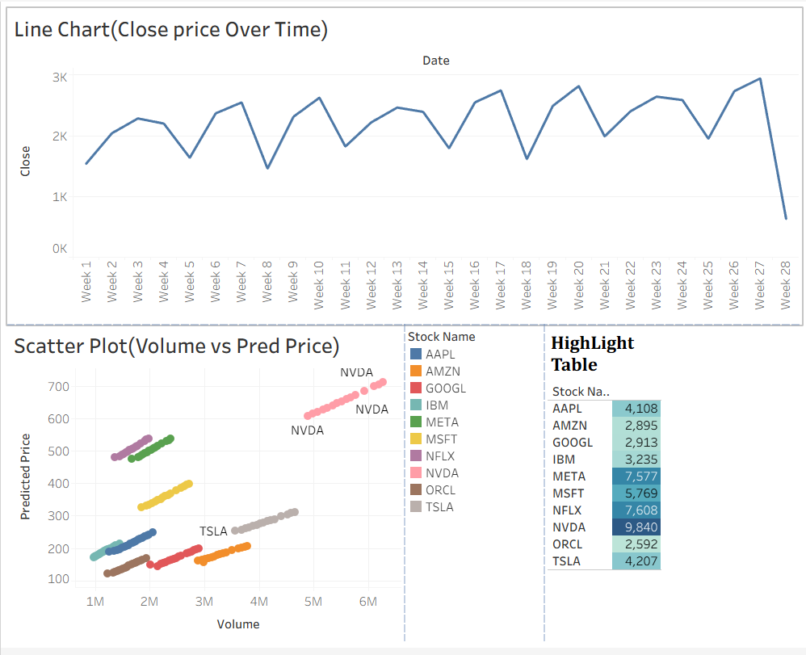

Part 2: Working with Power BI
- Open Power BI Desktop and import the same dataset.
- Explore the Interface: o Familiarize with Fields Pane, Visualizations Pane, Report View, Data View.
- Create Basic Visualizations:
  - Line Chart: Trend of Close Price over time.

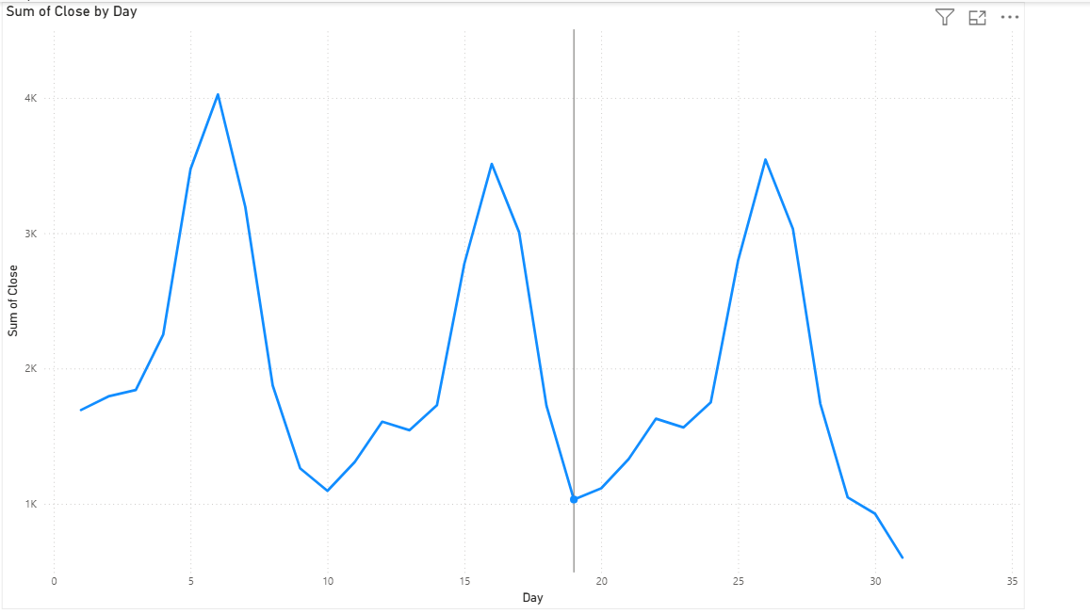
  - Bar Chart: Compare Predicted Price vs. Close Price.

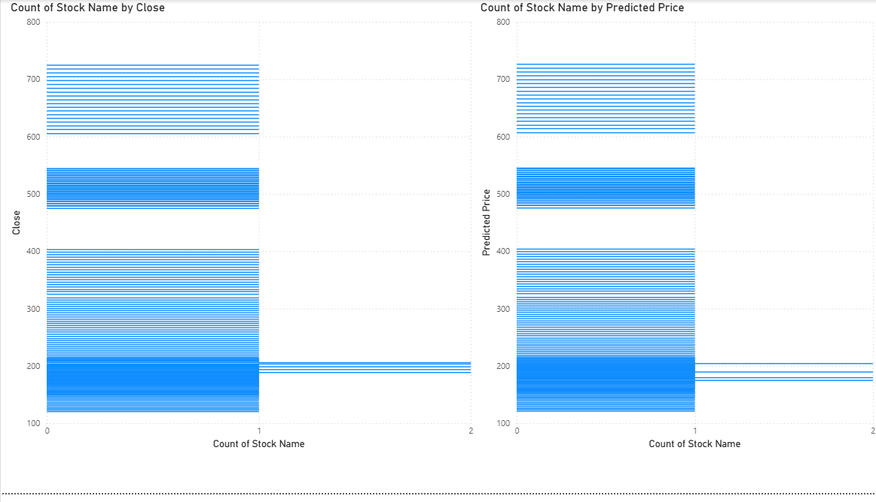

  - Card (KPI): Display average prediction error.

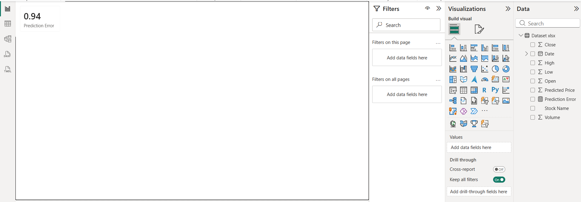

- Use Filters and Slicers:
  - Filter data based on Stock Name and Date.

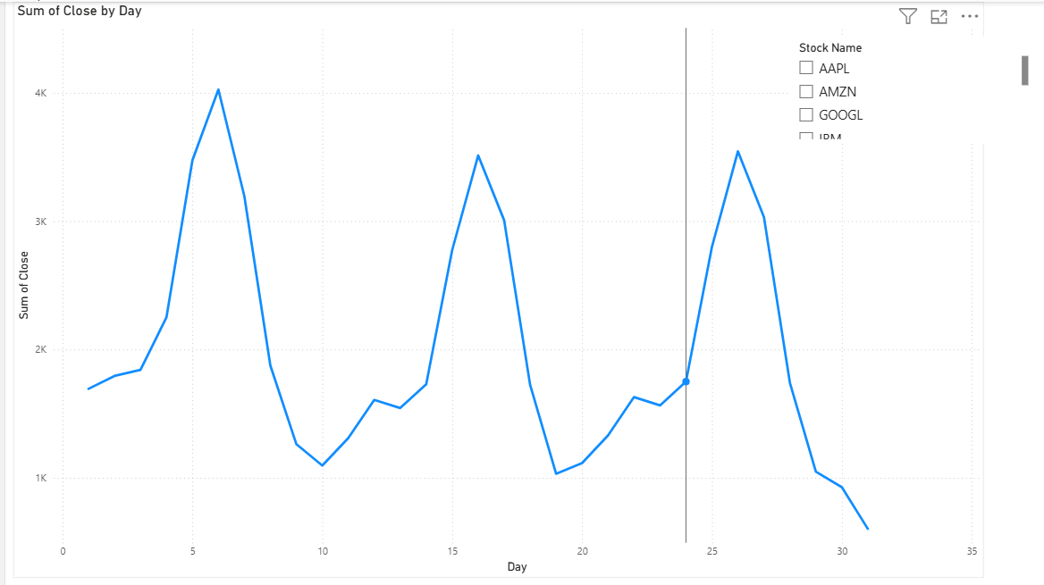

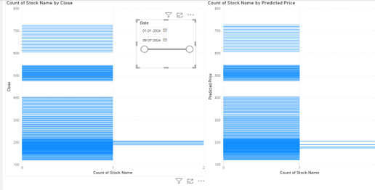

- Create a Simple Measure using DAX:
  - Example: Prediction Error = ABS(Predicted - Close)

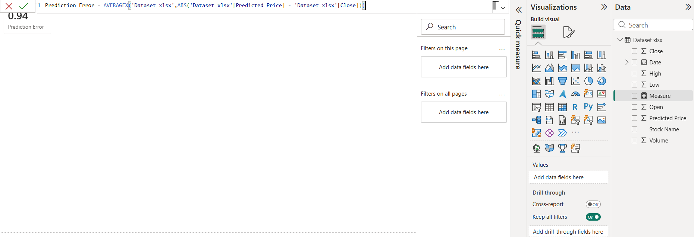
- Build a Report Page:
  - Arrange visuals in a single interactive page.

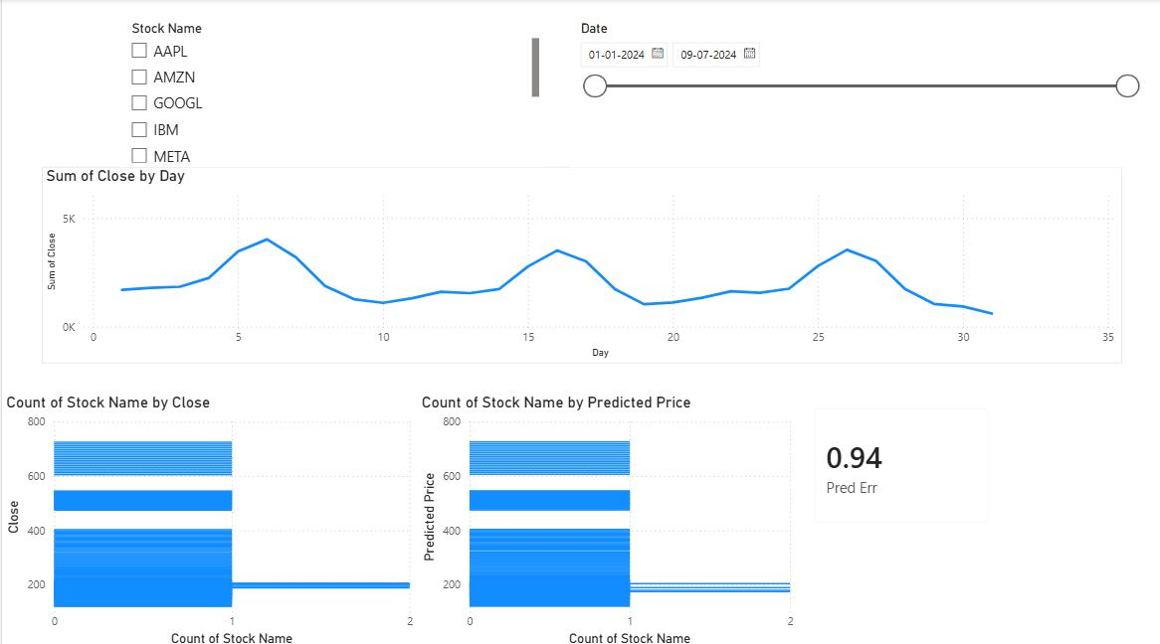

POST-LAB QUESTIONS (PROVIDE BRIEF ANSWERS TO THE FOLLOWING QUESTIONS)
1. Describe your experience with the Tableau interface. What components did you interact with?

The Tableau interface was intuitive and easy to navigate. I interacted with the Data Pane, Columns and Rows shelves, Marks Card, Show Me, Worksheets, and Dashboard to create and organize different visualizations.

2. How did you import the dataset into Tableau and Power BI?

In Tableau, I imported the dataset by selecting Connect → Text File and opening the CSV file. In Power BI, I used Home → Get Data → Text/CSV, selected the same dataset, and clicked Load to import it.

3. What types of visualizations did you create in both tools? List at least two per tool.

In Tableau, I created a Line Chart (Close Price over Time), a Scatter Plot (Volume vs. Predicted Price), and a Highlight Table. In Power BI, I created a Line Chart, a Clustered Bar Chart (Predicted Price vs. Close Price), and a Card to display the average prediction error.

4. How did you calculate the prediction error, and how was it displayed in your dashboard?

The prediction error was calculated using the formula ABS(Predicted Price − Close). In Tableau, it was created as a Calculated Field, while in Power BI, it was created as a DAX Measure and displayed in a Card (KPI) visual showing the average prediction error.

5. Which filtering or slicing techniques did you apply, and what insights did they reveal?

I applied Stock Name and Date Range filters in Tableau and corresponding Slicers in Power BI. These allowed me to analyze individual stock performance over selected dates and compare actual and predicted prices more effectively.

6. Compare the process of creating a line chart in Tableau vs. Power BI. What differences did you notice?

In Tableau, creating a line chart mainly involved dragging the Date and Close fields onto the Columns and Rows shelves, and Tableau automatically generated the chart. In Power BI, I first selected the Line Chart visual and then assigned the fields to the X-axis and Y-axis, making the process slightly more manual.

7. How did you organize the dashboard in Tableau and Power BI? What key elements did you include?

In Tableau, I combined the Line Chart, Scatter Plot, Highlight Table, and filters into an interactive dashboard. In Power BI, I arranged the Stock Name and Date slicers at the top, the Line Chart in the center, and the Bar Chart with the Prediction Error Card at the bottom.

8. Which tool (Tableau or Power BI) did you find more user-friendly for financial data visualization, and why?

I found Power BI slightly more user-friendly because its drag-and-drop interface and built-in DAX measures made creating reports and KPIs straightforward. However, Tableau provided more flexibility and visually appealing charts for interactive analysis.

9. What challenges did you face while creating visualizations or dashboards?

One challenge was ensuring that the Date column was recognized correctly as a date field and not as text. Another challenge was arranging the dashboard neatly and applying filters so that all visuals interacted correctly.

10. How can the knowledge gained from this lab be applied to real-world financial data analysis?

The skills learned in this lab can be used to build interactive dashboards for monitoring stock prices, comparing predicted and actual values, and identifying market trends. These techniques help analysts and investors make informed decisions using clear and data-driven visualizations

ASSESSMENT

Description |  | Max Marks | Marks Awarded
Pre Lab Exercise |  | 5
In Lab Exercise |  | 10
Post Lab Exercise |  | 5
Viva |  | 10
 | Total | 30
 |  | Faculty Signature

